**Experiment 02 – Displaying Hello World on Screen**

**Learning Objective:** To write a program to display hello world on screen on Android Studio.

**Tools:** Android Studio

**Theory:**

Android Studio:

Android Studio is the official integrated development environment (IDE) for Android application development. It is based on the IntelliJ IDEA, a Java integrated development environment for software, and incorporates its code editing and developer tools. To support application development within the Android operating system, Android Studio uses a Gradle- based build system, emulator, code templates, and GitHub integration. Every project in Android Studio has one or more modalities with source code and resource files. These modalities include Android app modules, Library modules, and Google App Engine modules.

It is an open source software platform and operating system for mobile devices which is based on the Linux kernel. It was developed by Google and later by the Open Handset Alliance (OHA). It allows writing managed code in the Java language and Kotlin language. It has its own virtual machine i.e. DVM (Dalvik Virtual Machine), which is used for executing the android application. Applications built in Android Studio are then compiled into the APK format for submission to the Google Play Store.

Android apps are built as a combination of components that can be invoked individually. For example, an activity is a type of app component that provides a user interface (UI). The "main" activity starts when the user taps the application's icon. One can also direct the user to an activity from elsewhere, such as from a notification or even from a different app. Other components, such as broadcast receivers and services, allow the application to perform background tasks without a UI.

To navigate transitions between stages of the activity lifecycle, the Activity class provides a core set of six callbacks: onCreate(), onStart(), onResume(), onPause(), onStop(), and onDestroy(). The system invokes each of these call-backs as an activity enters a new state. As the user begins to leave the activity, the system calls methods to dismantle the activity. In some cases, this dismantlement is only partial; the activity still resides in memory (such as when the user switches to another app), and can still come back to the foreground.

**Implementation:**

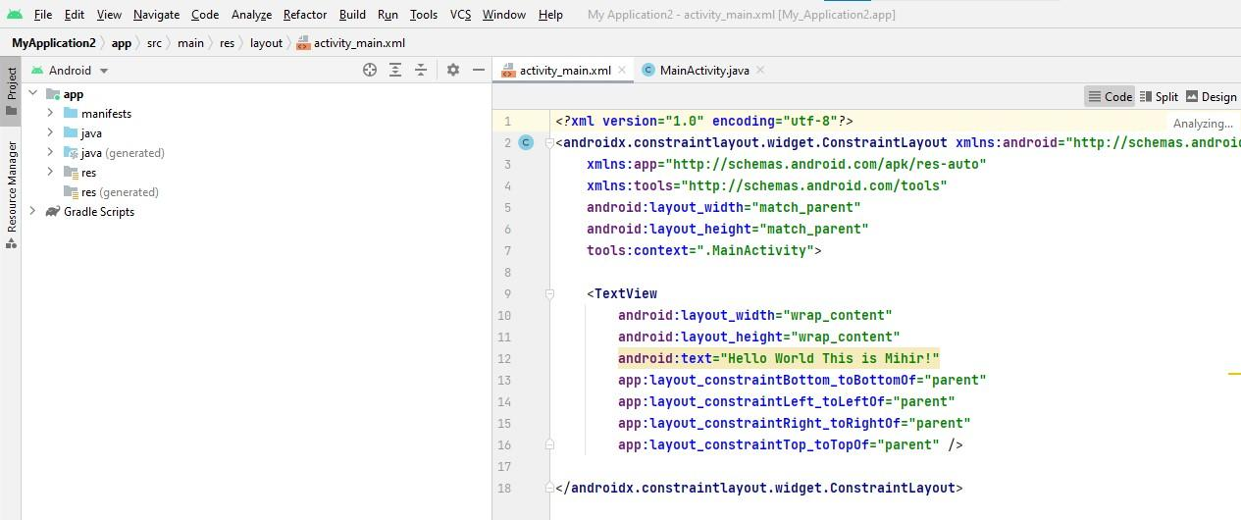

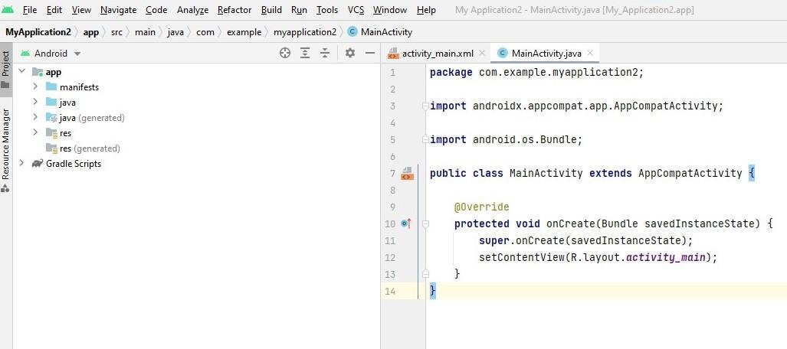

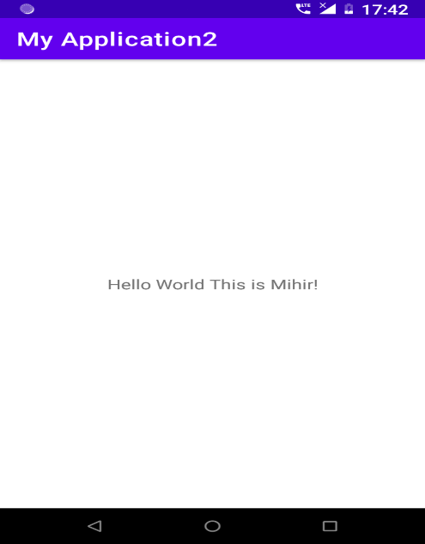**Output:**

Hello World!!

**Result and Discussion:** After performing the experiment I was able to explain the details of Android Virtual Device and execute a simple program on Android Studio.

**Learning Outcomes:** The student should have the ability to

LO1: **explain** the details of Android Virtual Device.

LO2: **execute** a simple program on Android Studio

**Course Outcomes:** Upon completion of the course students will be able to execute a simple program on Android Studio.

**Conclusion:** We understood in this experiment the concept of android studios and basic lifecycle of application in android studios. We implemented the basic hello world program which includes building an application and running it on Android Virtual Device.

For Faculty Use

|  |  |  |  |  |
| --- | --- | --- | --- | --- |
| **Correction Parameters** | **Formative Assessment [40%]** | **Timely completion of Practical [ 40%]** | **Attendance / Learning Attitude [20%]** |  |
| **Marks Obtained** |  |  |  |